(Paper) (RPF) Exam 2019 held on 05 January 2019 Reasoning (English)
Instructions
For the following questions answer them individually
Question 86. Replace the question mark with an option that follows the same logic applied in the first pair
4232:11::1291: ??
A 15
B 14
C 21
D 13
Question 87. Find the next number in the series.
173, 159, 180, 166, 187, ?
A 179
B 182
C 194
D 173
Question 88. In this question, three statements showing relationship have been given, which are followed by three conclusions i, ii and iii. Assuming that the given statements are true, find out which conclusion(s) is/are definitely true.
Statements: A ≤ M < Y; G < L > A ≥ D; D > I = N
Conclusions:
i) G > N
ii) L > N
iii) L > M
A Only i) and iii)
B Only ii)
C All follow
D Only i) and ii)
Question 89. In this question, three statements are given followed by four conclusions. You have to assume everything in the statement to be true, then consider the given conclusions together and decide which of them logically follows beyond a reasonable doubt from the information given in the statements.
Statements: Some girls are players. All boys are players. Some players are champions.
Conclusions:
i) Some boys are girls
ii) Some boys are players
iii) Some champions are girls
iv) Some champions are boys
A Only ii)
B Only i), ii) and iii)
C Only i)
D Only ii), iii) and iv)
Question 90. Pointing to a girl, a lady said, "She is my mother's mother's only daughter's only daughter's son's daughter." How is the girl related to the lady?
A Granddaughter
B Grandmother
C Aunt
D Daughter
Question 91. Each face of the dice is painted with Red, Green, Gray, Blue, Brown and Orange as shown in the given figure. What colour is painted on the face opposite to Orange colour?
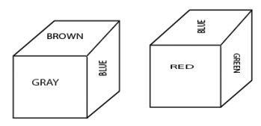
A GRAY
B BLUE
C GREEN
D RED
Question 92. In this question, relationship between different elements is shown in the statement. This statement is followed by two conclusions:
Statements: K = I < N ≤ D < E > R > A
Conclusion:
i) K < E
ii) E > A
Choose the appropriate one from the following options
(A)Only conclusion i follows.
(B) Only conclusion ii follows.
(C) Either conclusion i or ii follows.
(D) Neither conclusion i nor ii follows.
(E) Both conclusion i and ii follow.
A B
B E
C C
D A
Question 93. Choose the correct alternative which will complete the image pattern of the given image.
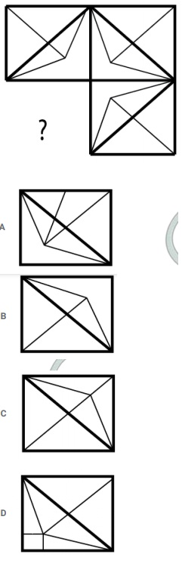
Question 94. If a mirror is placed on the shaded line, then which of the following options is the right image of the given figure?
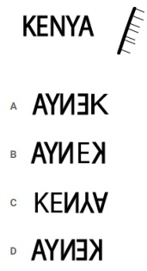
Question 95. Choose the correct water image of the given question from the given options.
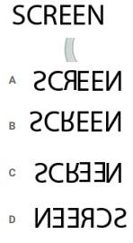
Question 96. Replace the question mark with an option that follows the same logic applied in the first pair
Pathology:Diseases::Paleontology: ??
A Fossils
B Insects
C Algae
D Diet
Question 97. How many straight lines are there in the given figure?
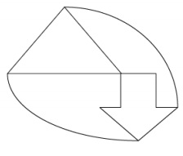
A 9
B 7
C 11
D 15
Question 98. Which one of the alternative will be the next figure from the given alternatives for the given series?
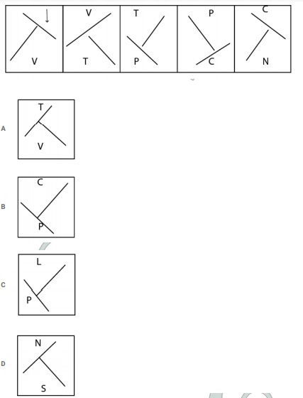
Question 99. How many Right angled triangles can be formed from the given figure?
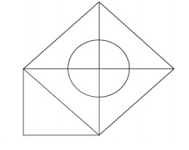
A 4
B 5
C 9
D 7
Question 100. Select the correct alternative from the following options which can form a complete square (3 out of 5 images given below) :
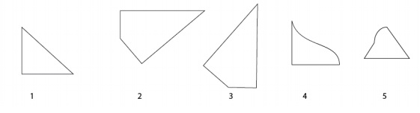
A 3,4,5
B 1,2,3
C 1,4,5
D 2,3,4
Question 101. In this question, a passage is given followed by a statement. Read the passage carefully and judge the statement based on the given passage. Delhi, the capital of India and one of the largest cities in the world, is under severe stress, thanks to urbanisation, increasing population and alarming levels of pollution. Studies have proved that transportation, industrial and residential sectors are the largest polluters, and that the citizens are exposed to high levels of nitrogen oxides (NOx), ozone (O3), black carbon (BC) and particulate matter (PM). The 2015 Global Burden of Disease report attributes about 1.09 million deaths in India to PM 2.51 and identifies air pollution to be among the top 10 health risks in the country. As per the World Health Organisation, 37 Indian cities are among the world’s top 100 cities with very high levels of PM10. Ozone formation requires both oxides of nitrogen (NOx) and volatile organic compounds (VOCs), along with sunlight and warm temperature. Therefore, the ground level ozone in the city exceeds the threshold limit largely during summer months.
Statement: The ground level ozone in the city doesn't exceed the limit largely during Summer. Choose the appropriate one from the following options
A -The statement is definitely true.
B -The statement is probably true.
C -The statement is cannot be determined.
D -The statement is definitely false.
A C
B D
C B
D A
Question 102. Find the next number in the series.
12, 15, 24, 51, 132, ?
A 294
B 268
C 345
D 375
Question 103. Four of the following five are alike in a certain way and so form a group. Which is the one that does not belong to that group?
P, T, H, X, R
A T
B P
C R
D X
Question 104. Replace the question mark with an option that follows the same logic applied in the first pair
GL:QV::DM: ??
A XO
B VO
C NW
D XP
Question 105. How many squares are there in the given figure?
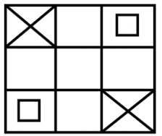
A 12
B 16
C 18
D 14
Question 106. In this question, a statement is given followed by two conclusions numbered i and ii. You have to assume everything in the statement to be true, then consider the two conclusions together and decide which of them logically follows beyond a reasonable doubt from the information given in the statement.
Statement: Weight is directly proportional to height.
Conclusion:
i) If weight increases, height remains the same
ii) If height increases, weight remains the same
Choose the appropriate one from the following options
(A) Only conclusion i follows
(B) Only conclusion ii follows
(C) Either i or ii follows
(D) Neither i nor ii follows and
(E) Both i and ii follow.
A B
B A
C D
D E
Question 107. Read the given information carefully and answer the questions that follow. Abi, Banu, Charu, Dev and Esha are five friends sitting in a row facing North (not necessarily in the same order). All five like five different sweets namely Laddu, Burfi, Jamun, Kathli and Peda.
i) One who likes Peda sits in the middle of the row.
ii) Charu and Banu sits on the either side of the one who like Peda.
iii) Banu like Laddu and Dev doesn't sit in any of the ends.
iv) The one who likes Burfi sits third to the left of the one who likes Jamun.
v) The one who likes Jamun sit at the extreme end of the line and Abi doesn't like Jamun.
Who likes Kathli?
A Charu
B Dev
C Esha
D Abi
Question 108. Four of the following five are alike in a certain way and so form a group. Which is the one that does not belong to that group?
ZWT, NKH, ROL, PMJ, YWU
A ZWT
B ROL
C PMJ
D YWU
Question 109. Replace the question mark with an option that follows the same logic applied in the first pair
Beautician:Parlour::Mechanic: ??
A Laboratory
B Cockpit
C Cabin
D Garage
Question 110. In this question, two statements are given followed by two conclusions numbered i and ii. You have to assume everything in the statements to be true, then consider the two conclusions together and decide which of them logically follows beyond a reasonable doubt from the information given in the statements.
Statements: All eyes are ears. Some ears are lips.
Conclusions:
i) Some eyes are lips
ii) No eye is lip
Choose the appropriate one from the following options
(A) Only conclusion i follows
(B) Only conclusion ii follows
(C) Either i or ii follows
(D) Neither i nor ii follows and
(E) Both i and ii follow
A C
B A
C B
D D
Question 111. In this question, a passage is given followed by a statement. Read the passage carefully and judge the statement based on the given passage. Delhi, the capital of India and one of the largest cities in the world, is under severe stress, thanks to urbanisation, increasing population and alarming levels of pollution. Studies have proved that transportation, industrial and residential sectors are the largest polluters, and that the citizens are exposed to high levels of nitrogen oxides (NOx), ozone (O3), black carbon (BC) and particulate matter (PM). The 2015 Global Burden of Disease report attributes about 1.09 million deaths in India to PM 2.51 and identifies air pollution to be among the top 10 health risks in the country. As per the World Health Organisation, 37 Indian cities are among the world’s top 100 cities with very high levels of PM10. Ozone formation requires both oxides of nitrogen (NOx) and volatile organic compounds (VOCs), along with sunlight and warm temperature. Therefore, the ground level ozone in the city exceeds the threshold limit largely during summer months.
Statement: Air pollution is one among the top 10 health risks in India.
Choose the appropriate one from the following options
A -The statement is definitely true.
B -The statement is probably true.
C -The statement is cannot be determined.
D -The statement is definitely false.
A C
B A
C D
D B
Question 112. In a certain code language, if ABUSE is coded as ZYFHV, then how is INSULT coded in that language?
A SOHFKI
B SOHFLI
C RMHFOG
D RMHFKG
Question 113. Read the following statements and answer the following question.
A@B means A is the mother of B
A#B means A is the father of B
A$B means A is the brother of B
A%B means A is the sister of B
Which of the following shows that 'P is the grandmother of R' ?
A P#Q#R
B P#Q@R
C P@Q@R
D P%Q#R
Question 114. Find the next number in the series.
5, 11, 25, 63, 173, ?
A 596
B 692
C 551
D 499
Question 115. B is the mother of M and A. Z, who is the husband of Y, is the son-in-law of O. Y is the sister of A. How is B related to O?
A Son
B Mother
C Wife
D Husband
Explanation:
Given that B(Female) is the mother of M & A(Siblings).
Z(Male), who is the husband of Y(Female) is the son-in-law of O. Y is the sister of A. It says M,A & Y are siblings. If Z is son-in-law of O, Y is daughter of O. As M,A& Y are siblings and given that B is their mother, Relationship between B & O is wife & Husband. Therefore, B is wife of O.
Family Diagram :
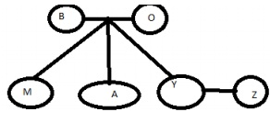
So, the answer would be option c)Wife
Question 116. In a certain code language, if MONTH is coded as TRSMY, then how is PLACE coded in that language?
A QUFJH
B QUFKH
C PTEIG
D PTEGI
Explanation:
In the word MONTH, Positions of M,O are interchanged & Positions of T,H are also interchanged. Middle letter N remains in the same position. Then the word will be OMNHT. Each letter in this word is added by 4 for it's position value in alphabets and replaced with letter in that position. For example, O is replaced with T and there are 4letters between them. (P,Q,R,S) Similar logic is used for word PLACE and code formed would be QUFJH
So, the answer would be option a)QUFJH
Question 117. Read the given information carefully and answer the questions that follow. Abi, Banu, Charu, Dev and Esha are five friends sitting in a row facing North (not necessarily in the same order). Each of them likes five different sweets namely Laddu, Burfi, Jamun, Kathli and Peda.
i) One who likes Peda sits in the middle of the row.
ii) Charu and Banu sits on the either side of the one who like Peda.
iii) Banu like Laddu and Dev doesn't sit in any of the ends.
iv) The one who likes Burfi sits third to the left of the one who likes Jamun.
v) The one who likes Jamun sit at the extreme end of the line and Abi doesn't like Jamun.
Which of the following statements is true with respect to the arrangement?
A Abi and the one who likes Laddu sit at the extreme ends
B Charu likes Burfi
C Dev sits between Abi and Charu
D Esha likes Kathli
Explanation:
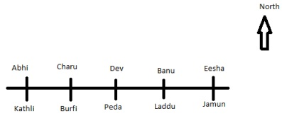
From the Given information, We can initially say that, Banu & Charu occupy 2nd and 4th positions. Also, Given that Dev doesn't sit on any of the ends. It clearly leads to a conclusion that Dev sits in the middle and he likes peda.
From 4th Point, "The one who likes Burfi sits third to the left of the one who likes Jamun.", We can say that the person who likes Jamun sits at the right side end as he has someone who likes burfi sitting left to him/her. We can also conclude that it would be Eesha who likes Jamun as it's given that Abi doesn't like Jamun.
Given that one who likes Burfi sits third to left of one who likes Jamun, therefore, Person in 2nd position likes Burfi and it would be Charu as given that Banu likes Laddu and Banu would be in 4th Position.
So charu likes burfi
Question 118. Find the next number in the series.
14, 31, 59, 121, 239, ?
A 468
B 471
C 481
D 478
Explanation:
We can observe that given series is in below pattern,
14,14 × 2 + 3 31 × 2 − 3 59 × 2 + 3 121 × 2 − 3 239 × 2 + 3
Next number would be 239 × 2 + 3 = 481
Question 119. Read the given information carefully and answer the questions that follow. Abi, Banu, Charu, Dev and Esha are five friends sitting in a row facing North (not necessarily in the same order). All five like five different sweets namely Laddu, Burfi, Jamun, Kathli and Peda.
i) One who likes Peda sits in the middle of the row.
ii) Charu and Banu sits on the either side of the one who like Peda.
iii) Banu like Laddu and Dev doesn't sit in any of the ends.
iv) The one who likes Burfi sits third to the left of the one who likes Jamun.
v) The one who likes Jamun sit at the extreme end of the line and Abi doesn't like Jamun.
Who sits third to the right of Charu?
A The one who likes Burfi
B The one who likes Jamun
C The one who likes Kathli
D The one who likes Laddu
Explanation:
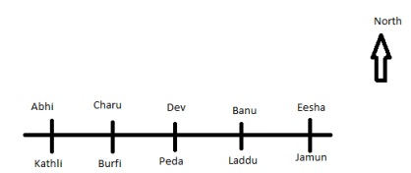
From the Given information, We can initially say that, Banu & Charu occupy 2nd and 4th positions. Also, Given that Dev doesn't sit on any of the ends. It clearly leads to a conclusion that Dev sits in the middle and he likes peda.
From 4th Point, "The one who likes Burfi sits third to the left of the one who likes Jamun.", We can say that the person who likes Jamun sits at the right side end as he has someone who likes burfi sitting left to him/her. We can also conclude that it would be Eesha who likes Jamun as it's given that Abi doesn't like Jamun.
Given that one who likes Burfi sits third to left of one who likes Jamun, therefore, Person in 2nd position likes Burfi and it would be Charu as given that Banu likes Laddu and Banu would be in 4th Position.
So, we can finalize all positions and sweets liked by them. so,Answer to the given question "Who sits third to the right of Charu?" would be "one who likes Jamun" from the formed figure.
Question 120. Four of the following five are alike in a certain way and so form a group. Which is the one that does not belong to that group?
Sleep, Nap, Slumber, Doze, Alive
A Sleep
B Nap
C Slumber
D Alive
Explanation:
Sleep,Nap, Slumber & Doze are forms of sleep whereas Alive is different from other four in terms of meaning. Hence, Option D is right choice.

